**APPENDIX 1**

**SCREEN SHOTS**

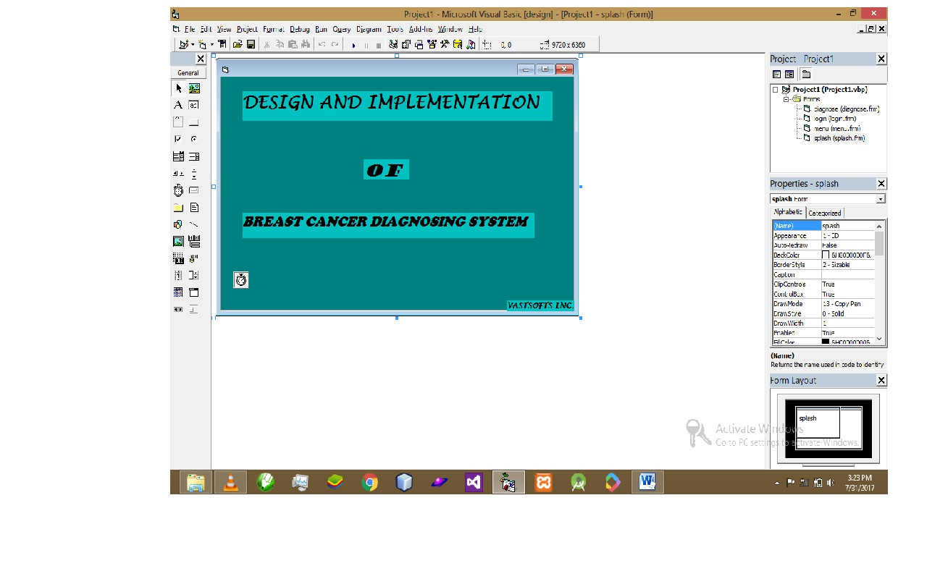

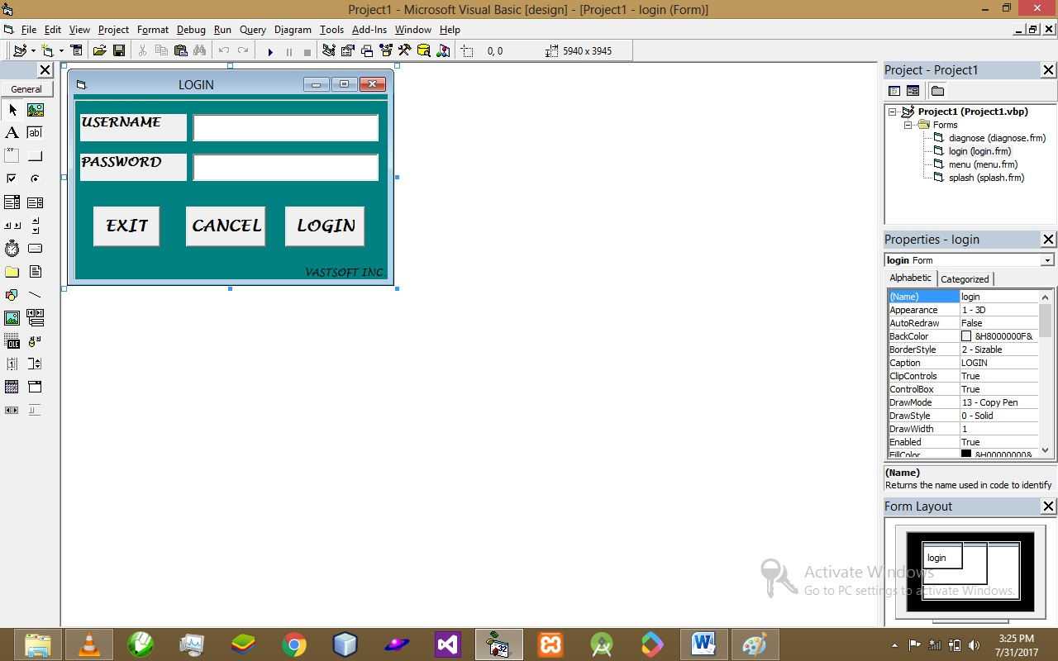

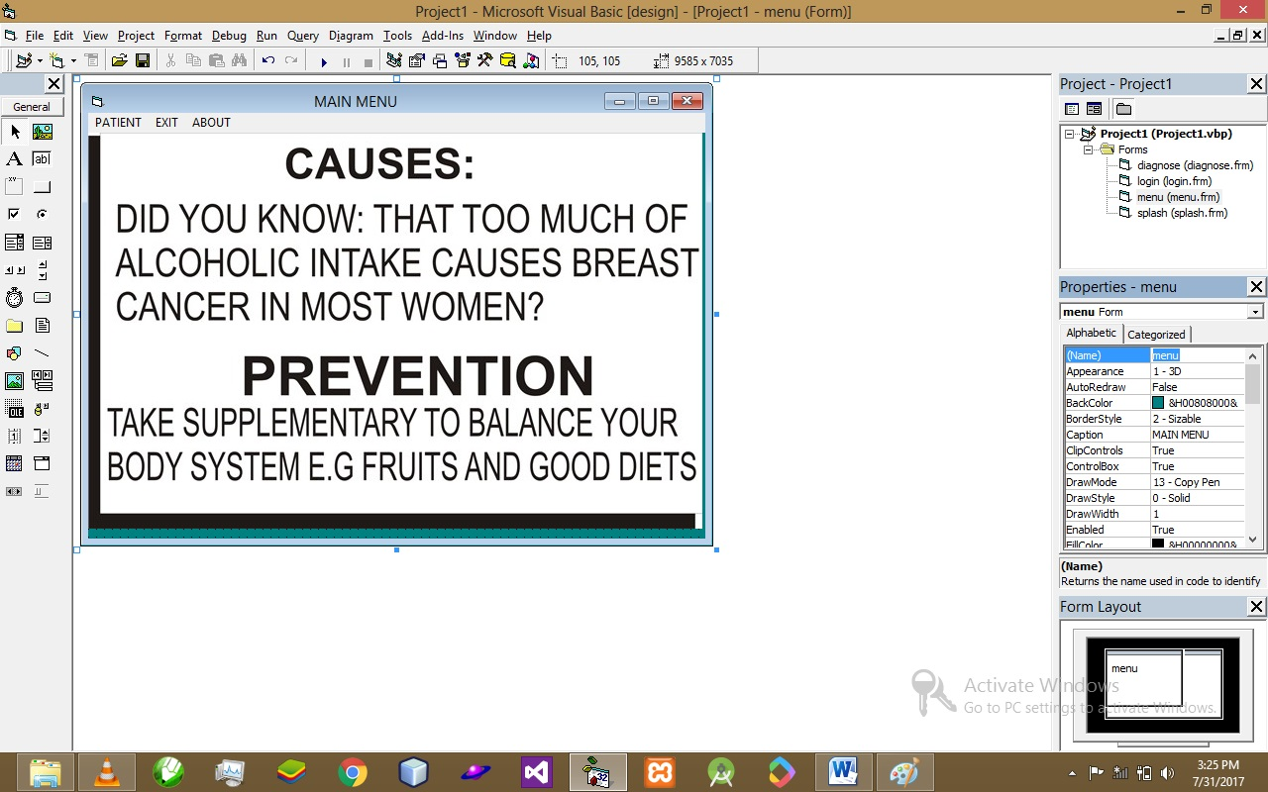

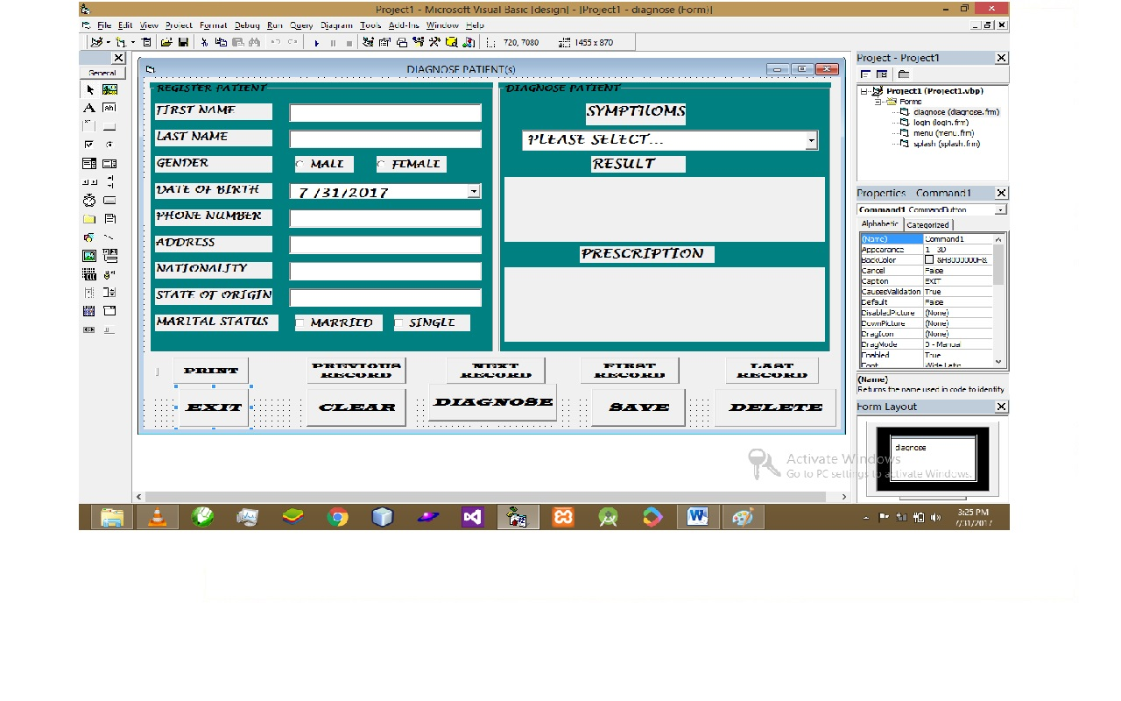

**APPENDIX 2**

**SOURCE CODE**

**SPLASH SCREEN CODE**

Private Sub Timer1_Timer()

Unload Me

login.Show

End Sub

**LOGIN SCREEN CODE**

Private Sub Command2_Click()

Text1.Text = ""

Text2.Text = ""

Text1.SetFocus

End Sub

Private Sub Command3_Click()

If Text1.Text = "pius" And Text2.Text = "pius" Then

MsgBox "LOGIN SUCCESSFUL", , "LOGIN"

Unload Me

menu.Show

Else

MsgBox "INVALID PARAMETERS", , "LOGIN"

Me.Refresh

End If

End Sub

**MAIN MENU CODE**

Private Sub FRMDIAGNOSE_Click()

Unload Me

diagnose.Show

End Sub

Private Sub MNUABOUT_Click()

MsgBox "VERSION 1.0... POWERED BY:VASTSOFTS INC.", , "BREAST CANCER"

End Sub

Private Sub MNUEXIT_Click()

Dim EXITT As String

EXITT = MsgBox("SURE TO EXIT", vbYesNo, "EXIT")

If EXITT = vbYes Then

Unload Me

Else: Me.Refresh

End If

End Sub

**DIAGNOSING SCREEN CODE**

Dim CON As New ADODB.Connection

Dim REC As New ADODB.Recordset

Private Sub Command1_Click()

Dim EXITT As String

EXITT = MsgBox("SURE TO EXIT", vbYesNo, "EXIT")

If EXITT = vbYes Then

Unload Me

Else: Me.Refresh

End If

End Sub

Private Sub Command10_Click()

REC.MoveFirst

display

End Sub

Private Sub Command11_Click()

REC.MoveLast

display

End Sub

Private Sub Command12_Click()

REC.AddNew

End Sub

Private Sub Command2_Click()

Text1.Text = ""

Text2.Text = ""

Text3.Text = ""

Text4.Text = ""

Text5.Text = ""

Text6.Text = ""

DTPicker1.Value = "12/31/1999"

Combo1.Text = "PLEASE SELECT..."

PRESCRIPTION.Caption = ""

RESULT.Caption = ""

MsgBox "ALL FIELDS CLEARED", , "CANCER DIAGNOSE"

End Sub

Private Sub Command3_Click()

If Combo1.Text = " REDNESS OF THE BREAST?" Then

RESULT.Caption = "COULD BE REACTION OF GENETICS OR MUCH ALCOHOLIC CONSUMPTION"

PRESCRIPTION.Caption = "TAKE 2 TABLETS OF HORMONE THERAPY AND IF REDNESS PERSIST, CONSULT YOUR PHYSICIAN"

ElseIf Combo1.Text = "PAINS ON THE BREAST OR ROUND THE ARMPIT?" Then

RESULT.Caption = "COULD BE BODY WEIGHT OR YOU COULD BE AGING"

PRESCRIPTION.Caption = "TAKE 2 TABLETS OF PANADOL AND BIOLOGICAL THERAPY TO EASE PAINS"

ElseIf Combo1.Text = "DISCHARGE OF UNNECCESSARY FLUID?" Then

RESULT.Caption = "COULD BE MUCH ALCOHOLIC INTAKE OR RADIATION TO EXPOSURE"

PRESCRIPTION.Caption = "TAKE RADIATION THERAPY OR YOU UNDERGO A SURGERY"

ElseIf Combo1.Text = "RASH ON QTHE NIPPLE?" Then

RESULT.Caption = "COULD BE INFECTION OR DUCTAL CARCINOMA CANCER"

PRESCRIPTION.Caption = " UNDERGO A SURGERY OR YOU TAKE CHEMOTHERAPY THOUGH MAY BE HARMFUL TO SKIN"

ElseIf Combo1.Text = "CHANGE IN THE SIZE OF THE NIPPLE?" Then

RESULT.Caption = "CAUSED BY DENSED BREAST TISSUE"

PRESCRIPTION.Caption = "UNDERGO A SURGERY IMMEDIATELY"

ElseIf Combo1.Text = "PEELING OF SKIN ON THE BREAST SKIN?" Then

RESULT.Caption = "COULD BE MUCH ALCOHOLIC INTAKE AND HORMONE TREATMENT"

PRESCRIPTION.Caption = "TAKE HORMONE AND GENETIC THERAPY"

End If

End Sub

Private Sub Command4_Click()

If Text1.Text = "" Or Text2.Text = "" Or Text3.Text = "" Or Text4.Text = "" Or Text5.Text = "" Or Text6.Text = "" Or Combo1.Text = "" Or RESULT.Caption = "" Or PRESCRIPTION.Caption = "" Then

MsgBox "EMPTY FEILD(s) DISCOVERED", , "DIAGNOSE"

Else

REC.Fields("FIRST_NAME").Value = Text1.Text

REC.Fields("LAST_NAME").Value = Text2.Text

If Option1.Value = True Then

REC.Fields("GENDER") = Option1.Caption

Else

REC.Fields("GENDER") = Option2.Caption

End If

REC.Fields("DOB").Value = DTPicker1.Value

REC.Fields("PHONE").Value = Text3.Text

REC.Fields("ADDRESS").Value = Text4.Text

REC.Fields("NATIONALITY").Value = Text5.Text

REC.Fields("STATE").Value = Text6.Text

If Check1.Value = True Then

REC.Fields("MARITAL") = Check1.Caption

Else

REC.Fields("MARITAL") = Check2.Caption

End If

REC.Fields("SYMPTHOMS").Value = Combo1.Text

REC.Fields("RESULT").Value = RESULT.Caption

REC.Fields("PRESCRIPTION").Value = PRESCRIPTION.Caption

MsgBox "SUCCESSFULLY SAVED TO DATABASE", , "DIAGNOSE"

REC.Update

End If

End Sub

Private Sub Command6_Click()

REC.Fields("FIRST_NAME").Value = Text1.Text

REC.Fields("LAST_NAME").Value = Text2.Text

If Option1.Value = True Then

REC.Fields("GENDER") = Option1.Caption

Else

REC.Fields("GENDER") = Option2.Caption

End If

REC.Fields("DOB").Value = DTPicker1.Value

REC.Fields("PHONE").Value = Text3.Text

REC.Fields("ADDRESS").Value = Text4.Text

REC.Fields("NATIONALITY").Value = Text5.Text

REC.Fields("STATE").Value = Text6.Text

If Check1.Value = True Then

REC.Fields("MARITAL") = Check1.Caption

Else

REC.Fields("MARITAL") = Check2.Caption

End If

REC.Fields("SYMPTHOMS").Value = Combo1.Text

REC.Fields("RESULT").Value = RESULT.Caption

REC.Fields("PRESCRIPTION").Value = PRESCRIPTION.Caption

MsgBox "SUCCESSFULLY DELETED FROM DATABASE", , "DIAGNOSE"

REC.Delete

End Sub

Sub display()

Text1.Text = REC!first_name

Text2.Text = REC!last_name

If REC!gender = "male" Then

Option1.Value = True

Else: Option2.Value = True

End If

DTPicker1.Value = REC!dob

Text3.Text = REC!phone

Text4.Text = REC!address

Text5.Text = REC!nationality

Text6.Text = REC!State

If REC!marital = "married" Then

Check1.Value = True

Else

End If

Combo1.Text = REC!sympthoms

RESULT.Caption = REC!RESULT

PRESCRIPTION.Caption = REC!PRESCRIPTION

MsgBox "records displayed"

End Sub

Private Sub Command7_Click()

Me.PrintForm

End Sub

Private Sub Command8_Click()

REC.MovePrevious

If REC.BOF Then

REC.MoveLast

display

Else

display

End If

End Sub

Private Sub Command9_Click()

REC.MoveNext

If REC.EOF Then

REC.MoveFirst

display

Else

display

End If

End Sub

Private Sub Form_Load()

CON.Open "provider=microsoft.jet.oledb.4.0;Data Source=C:\Users\DANIEL IBANGA\Desktop\BREAST CANCER DIAGNOSE\BREAST_CANCER.mdb;PERSIST SECURITY INFO = FALSE"

REC.Open "SELECT * FROM DIAGNOSE", CON, adOpenDynamic, adLockPessimistic

Combo1.AddItem " REDNESS OF THE BREAST?"

Combo1.AddItem "PAINS ON THE BREAST OR ROUND THE ARMPIT?"

Combo1.AddItem "DISCHARGE OF UNNECCESSARY FLUID?"

Combo1.AddItem "RASH ON QTHE NIPPLE?"

Combo1.AddItem "CHANGE IN THE SIZE OF THE NIPPLE?"

Combo1.AddItem "PEELING OF SKIN ON THE BREAST SKIN?"

display

End Sub